Collection Framework

1)

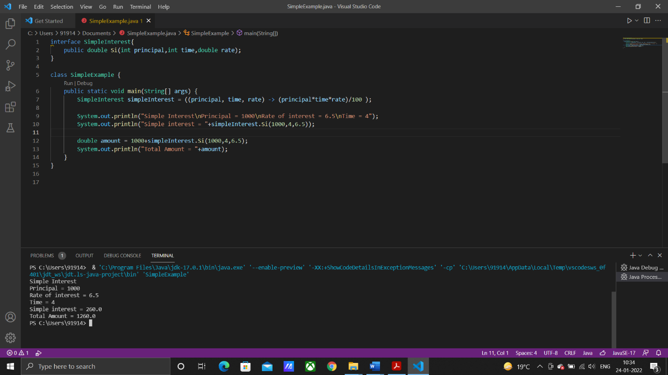

2)

Reasons:

* You can use var only for local variables
* You cannot use var in Lambda expressions
* You cannot use var for method signatures

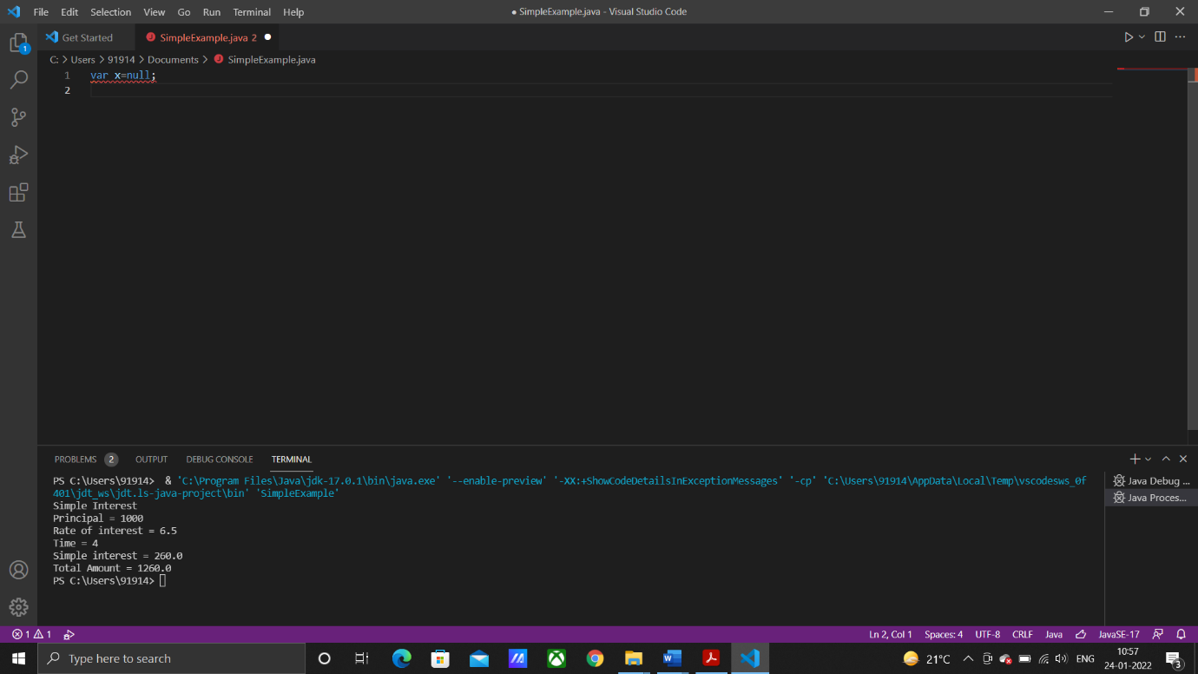

3)

